**Objective Answers:**

1. Are there any tables with duplicate or missing null values? If so, how would you handle them.

To identify duplicate or missing null values, we can perform the following SQL queries:

* **Check for Duplicate or Missing Null Values:**

**Find Duplicate Values:**

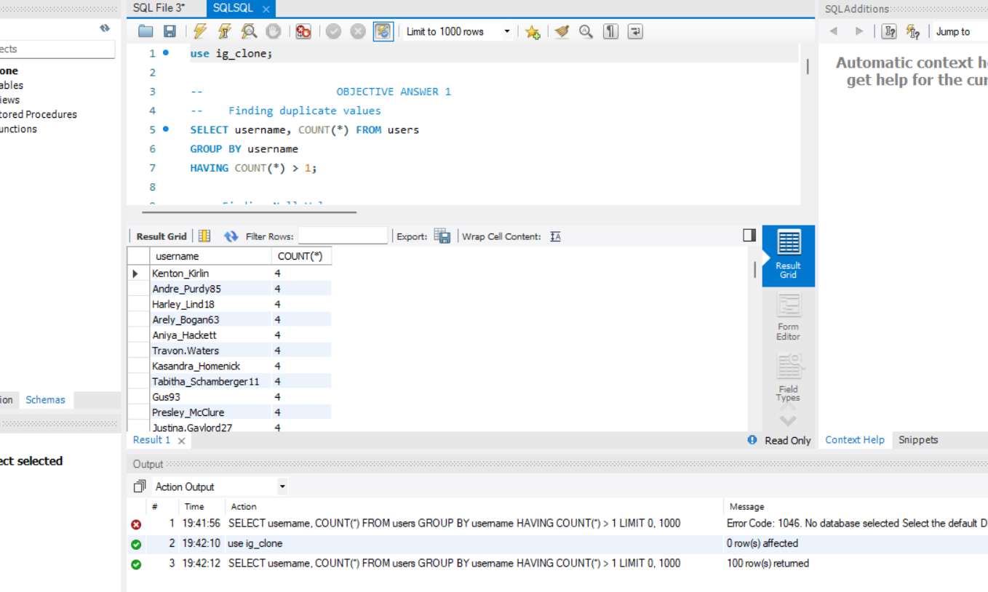

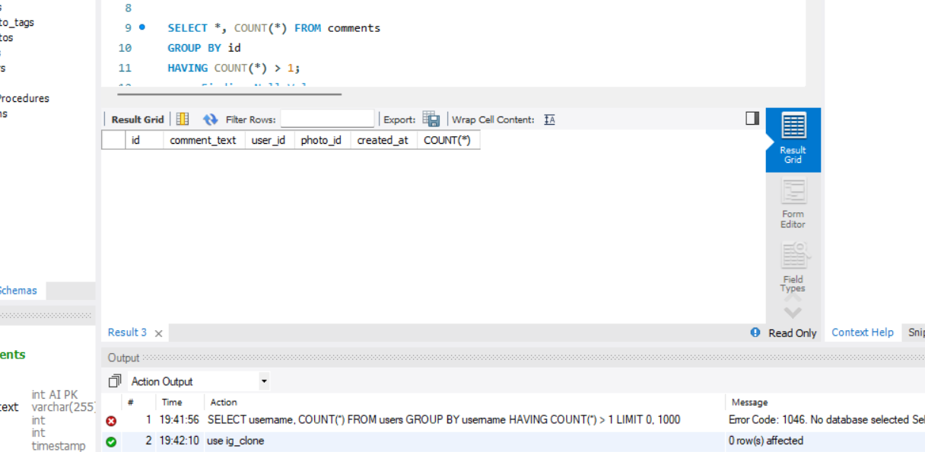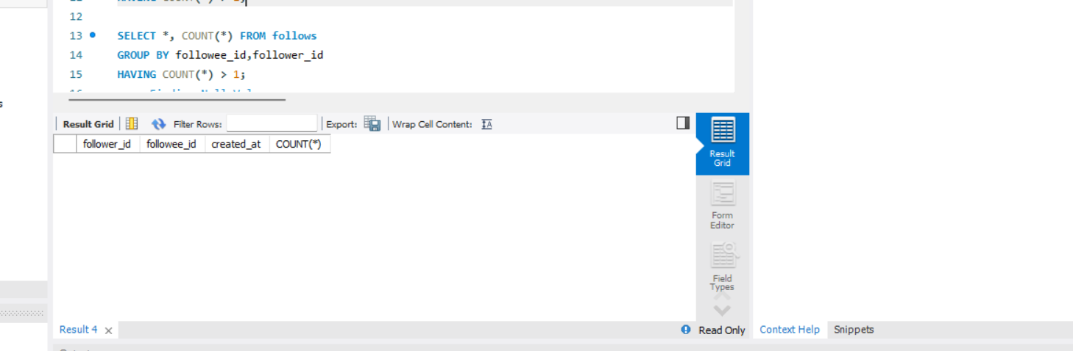

**Find Missing Null Values:**

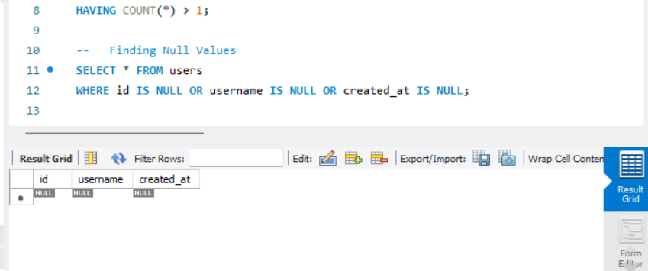

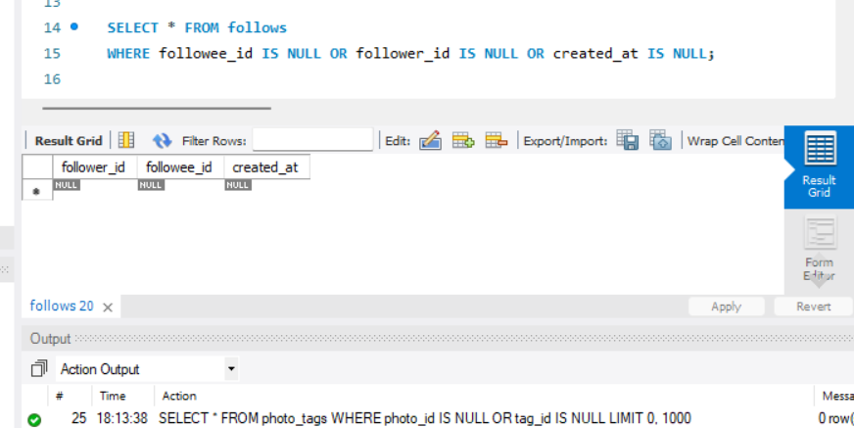

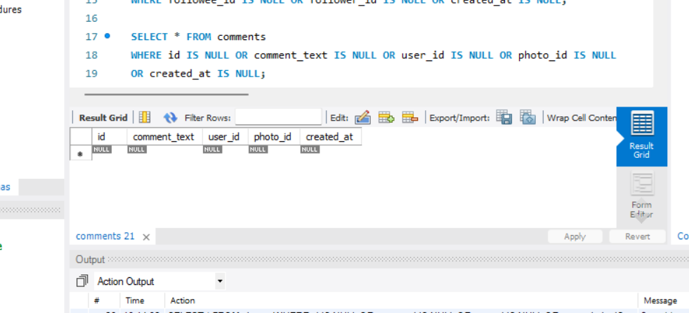

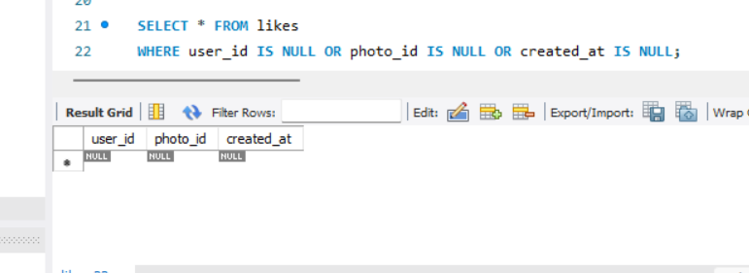

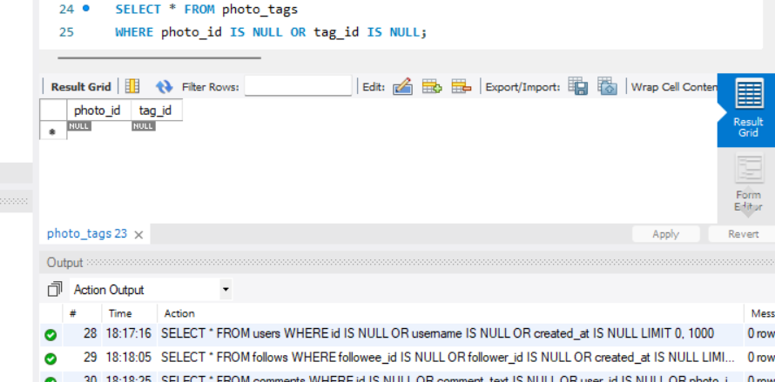

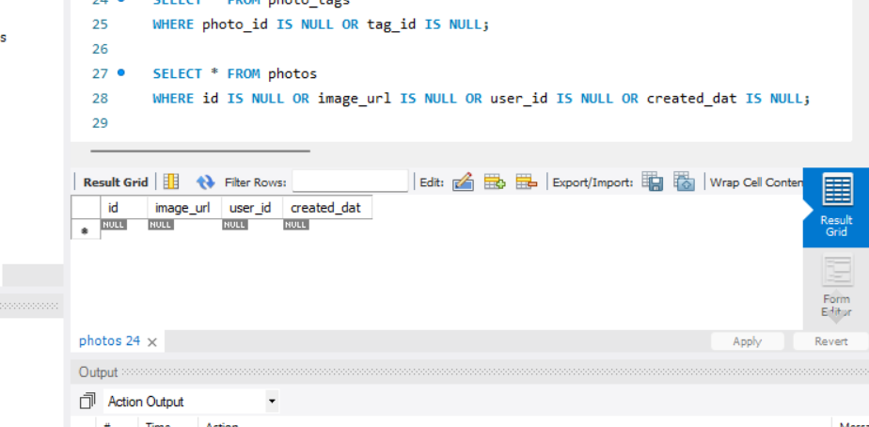

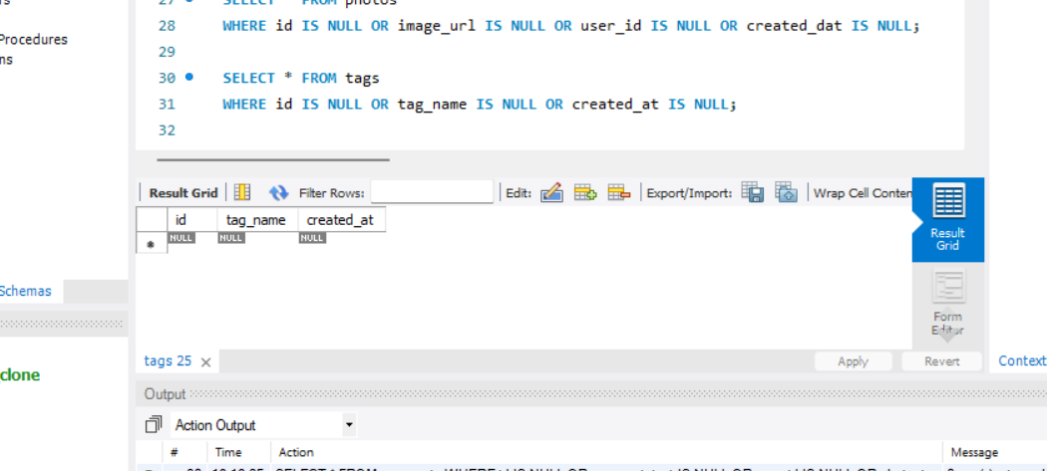

* **Handling Null Values:**

**Removing duplicates:** Use DELETE or UPDATE statements to clean up duplicates.

**Handling nulls:** You can use default values or update the rows with missing information, or exclude them from analysis if appropriate.

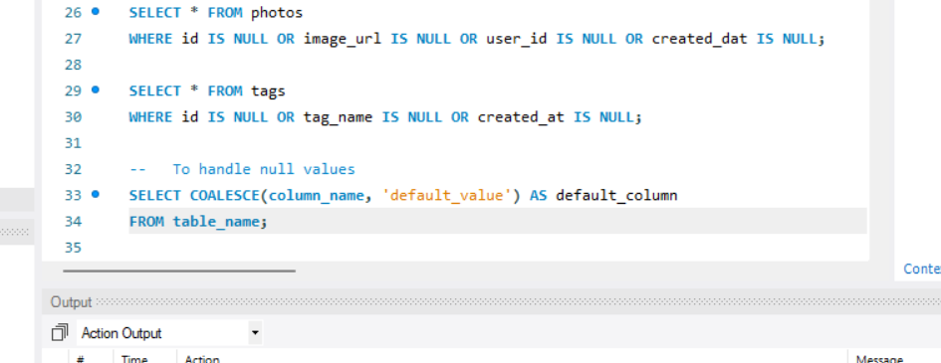

1. What is the distribution of user activity levels (e.g., number of posts, likes, comments) across the user base?

**Reference:**

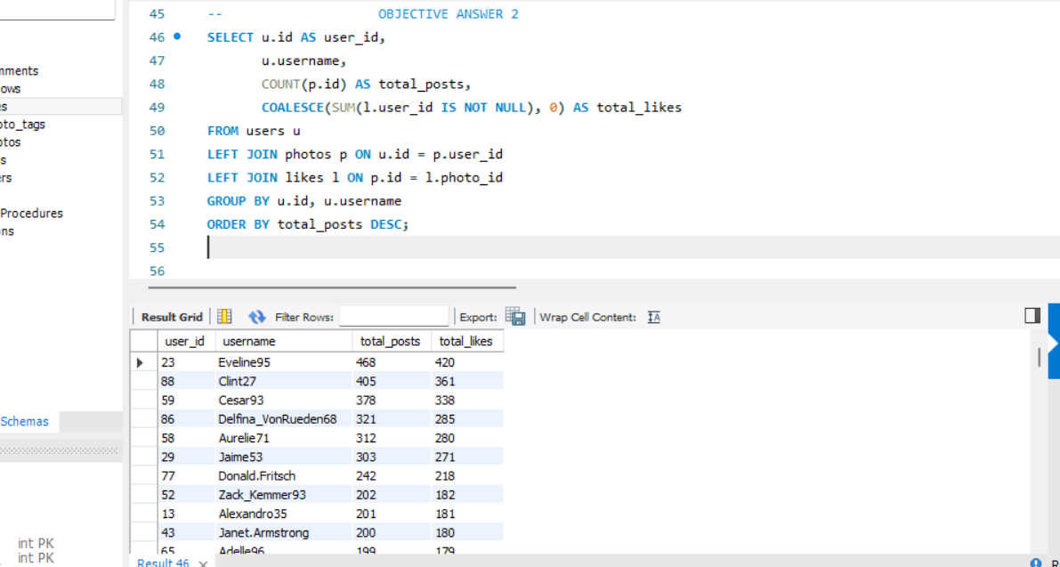

**Visualization:**

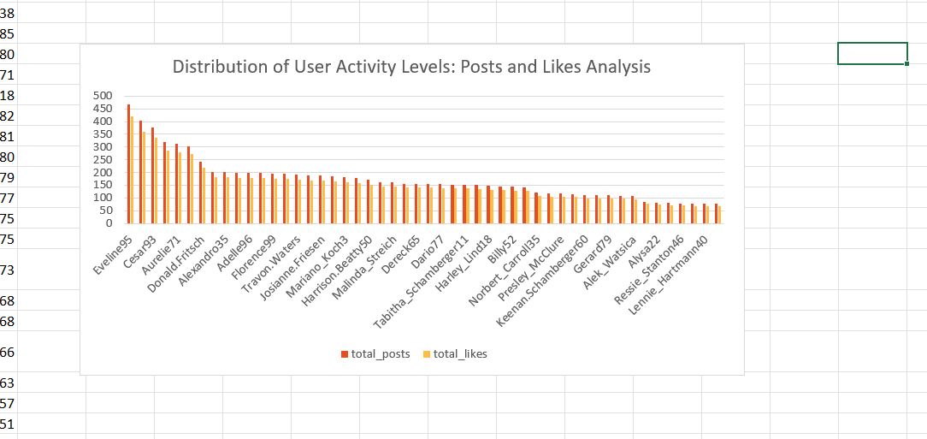

By visualizing user activity levels with bar charts and box plots, you can effectively communicate the distribution of posts and likes across your user base. This analysis can inform future engagement strategies and highlight opportunities to encourage more activity from less engaged users.

1. Calculate the average number of tags per post (photo_tags and photos tables).

**Reference:**

The average no. of tags per post as follows:

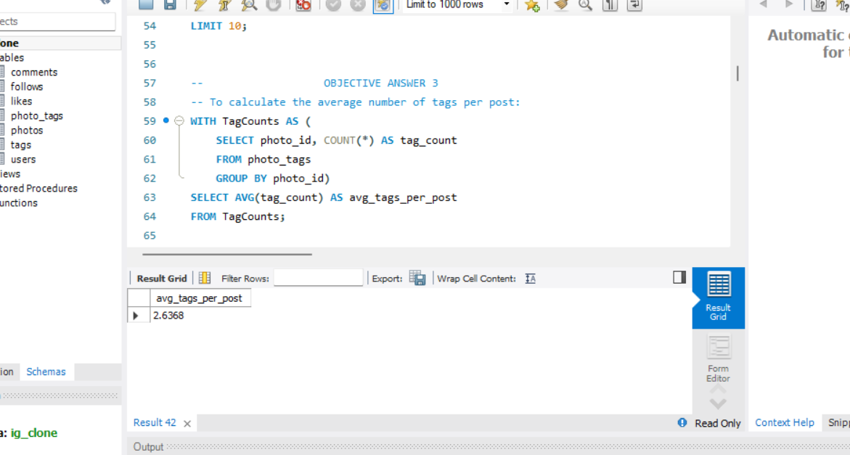

1. Identify the top users with the highest engagement rates (likes, comments) on their posts and rank them.

**Reference:**

To rank users by engagement (likes, comments) on their posts as follows:

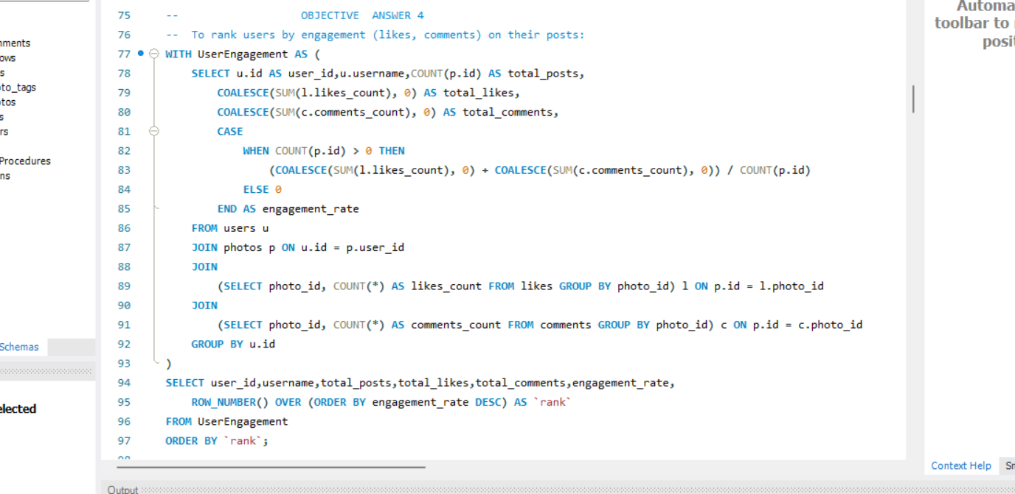

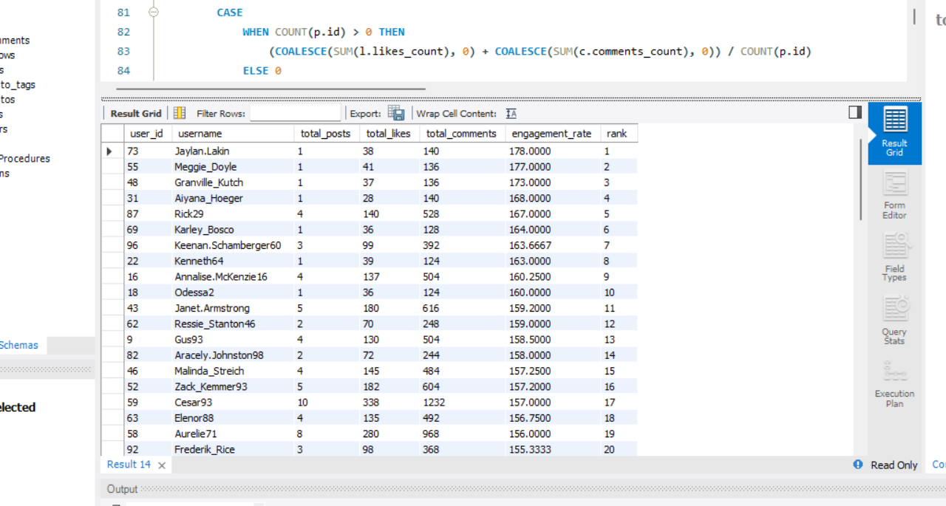

1. Which users have the highest number of followers and followings?

**Reference:**

To find users with the highest number of followers and followings as follows:

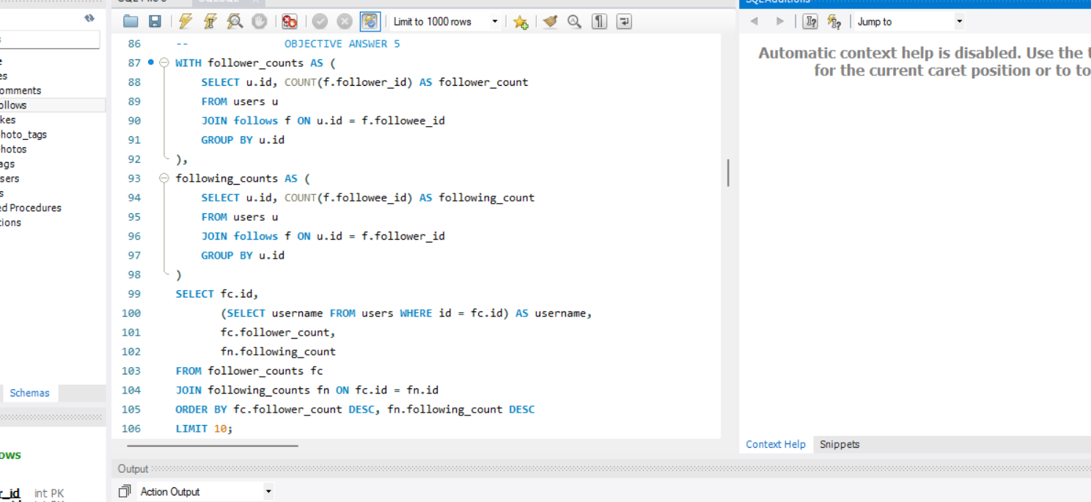

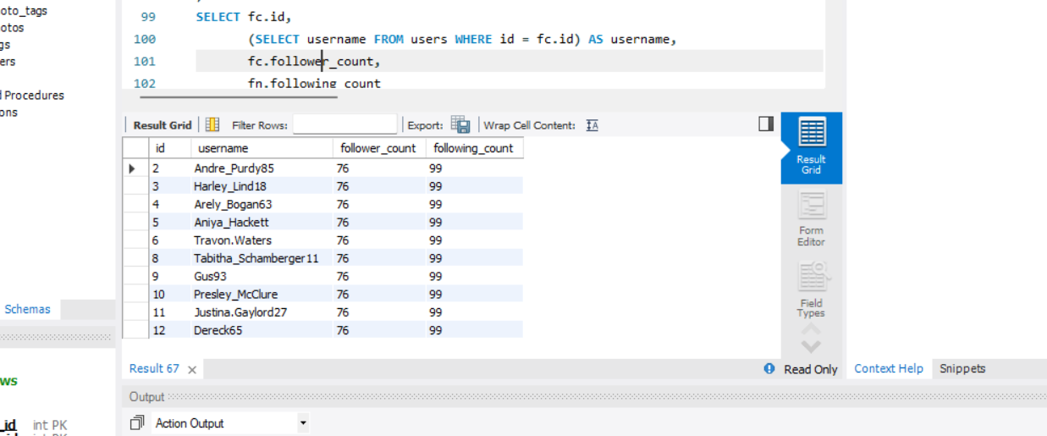

1. Calculate the average engagement rate (likes, comments) per post for each user.

**Reference:**

The average engagement rate per post for each user as follows: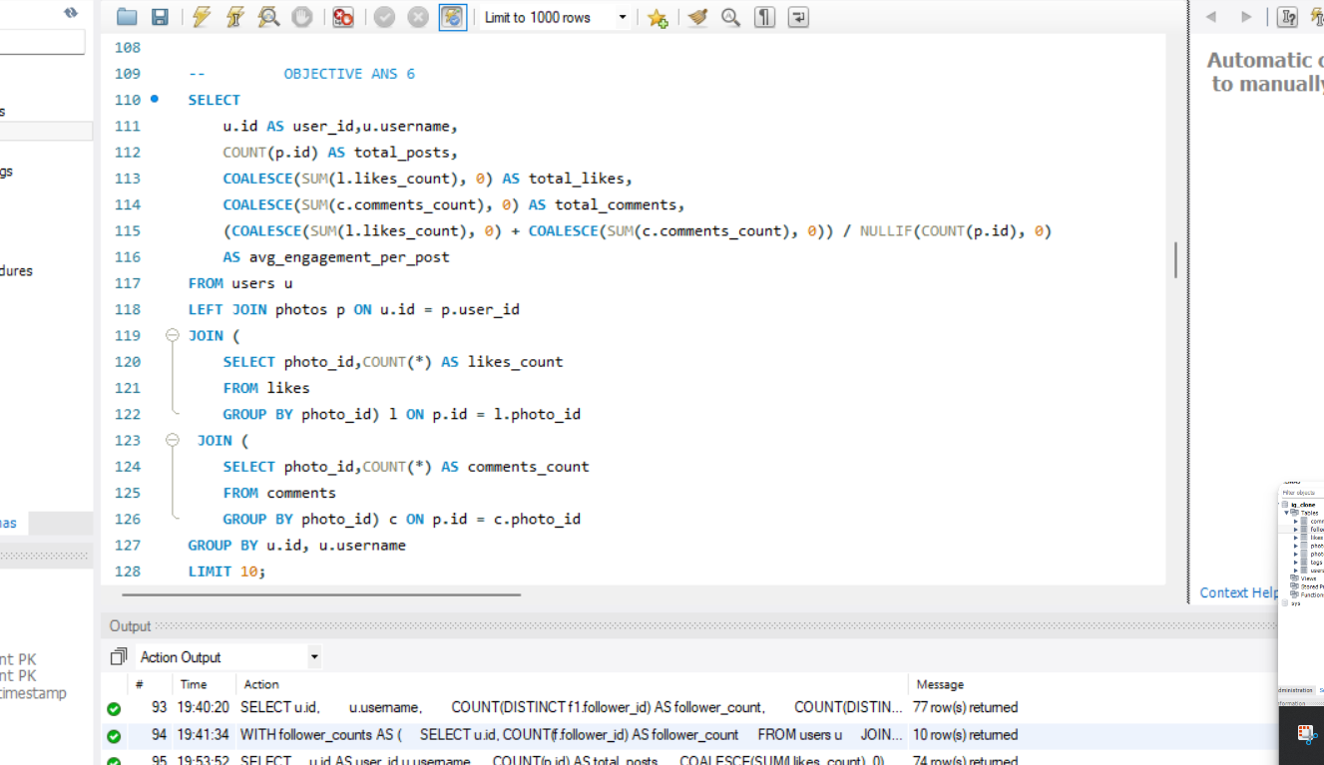

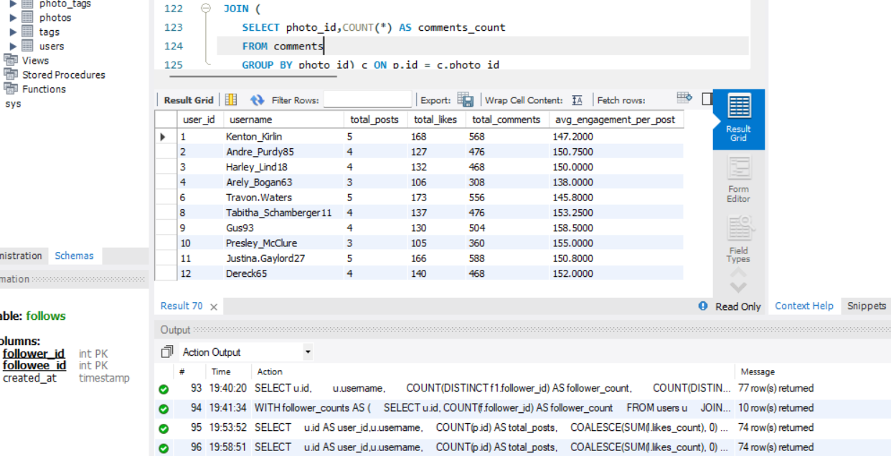

1. Get the list of users who have never liked any post (users and likes tables).

**Reference:**

Users who have never liked any post as follows:

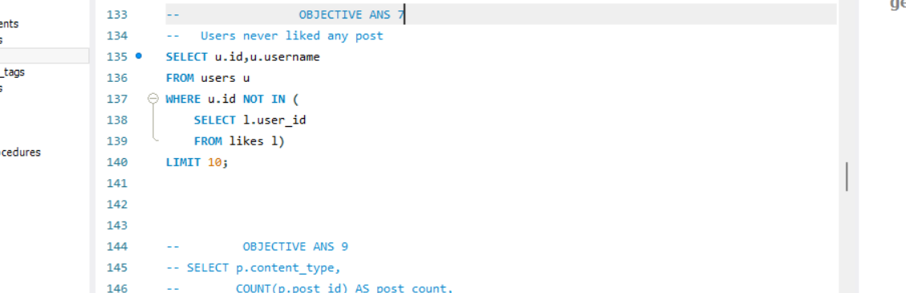

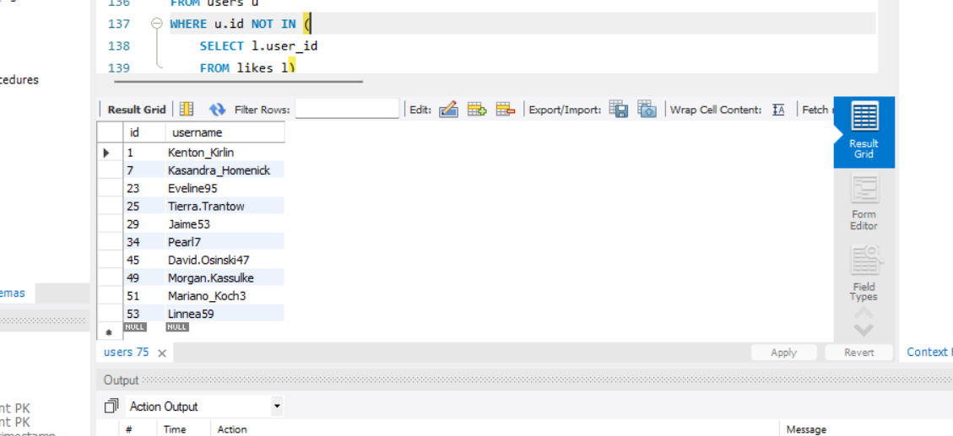

1. How can you leverage user-generated content (posts, hashtags, photo tags) to create more personalized and engaging ad campaigns?

**Reference1:**



**Visualization1:**



**Reference2:**

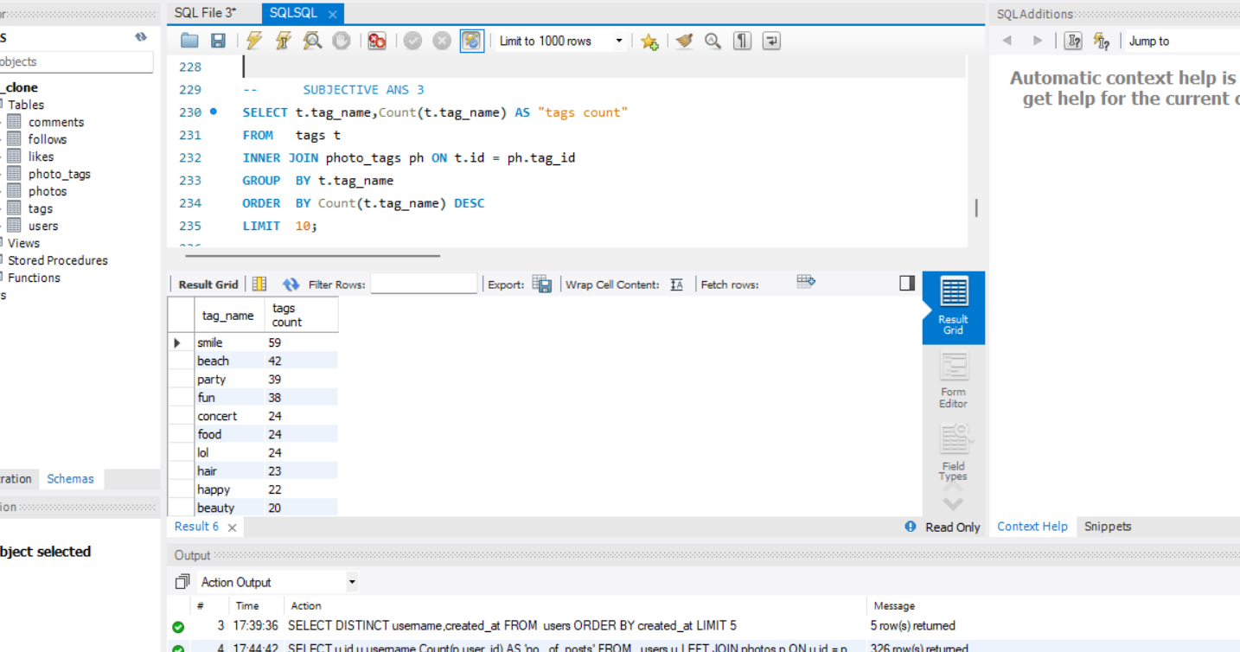

**Visualization2:**

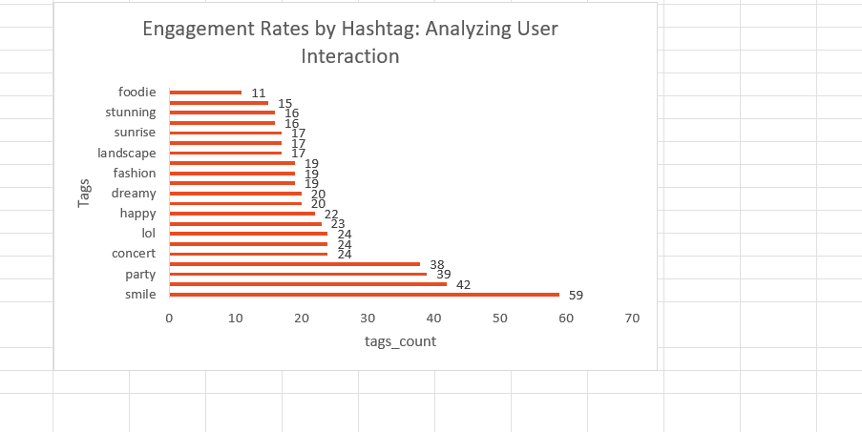

User-generated content (UGC) can be a powerful tool to create more personalized and engaging ad campaigns. Here are some ways to leverage UGC:

**1. User-generated content ads:** Use UGC in your ads to showcase real customers using your product or service. This can increase credibility and trust with potential customers.

Example: A fashion brand creates an ad featuring a customer wearing their clothes and showcasing their own style.

**2. Influencer partnerships:** Partner with influencers who have a large following and are passionate about your brand. Ask them to create content featuring your product or service and re-share it on their social media channels.

Example: A fitness brand partners with a popular fitness influencer to create a workout routine featuring their products.

**3. Hashtag campaigns:** Create a branded hashtag and encourage customers to use it when sharing their own content related to your brand. Monitor the hashtag and re-share the best content in your ads.

Example: A travel brand creates a hashtag #MyTravelAdventures and encourages customers to share their travel photos and stories. The brand then re-shares the best content in their ads.

**4. Photo tags:** Allow customers to tag your brand or products in their photos, and then use those photos in your ads.

Example: A food brand allows customers to tag them in photos of

**5. Social listening:** Monitor social media conversations about your brand and respond to customer comments and questions. This can help build trust and increase engagement with potential customers.

Example: A beauty brand monitors social media conversations about their products and responds to customer questions and comments, providing personalized advice and recommendations.

**6. Influencer takeovers:** Allow influencers to take over your social media accounts for a day, creating content that showcases your brand and products from their perspective.

Example: A fashion brand allows a popular fashion influencer to take over their Instagram account for a day, creating content featuring their clothes and accessories.

**7. User-generated content galleries:** Create a gallery on your website featuring customer-generated content, such as photos or videos of customers using your products or services.

Example: A home decor brand creates a gallery on their website featuring customer photos of their products in the customer's home, showcasing the versatility and functionality of the products.

**8. Contests and giveaways**: Host contests and giveaways that encourage customers to share their own content related to your brand, such as photos or videos featuring your products or services.

Example: A sports brand hosts a contest where customers can enter by sharing a photo or video of them playing their favourite sport using the brand's products, with a chance to win a prize pack.

**9. Personalized content**: Use UGC to create personalized content for each customer, such as customized ads or email campaigns based on their interests and behaviours.

Example: A fashion brand uses UGC to create personalized ads for each customer, showcasing products that match their style and preferences.

1. Are there any correlations between user activity levels and specific content types (e.g., photos, videos, reels)? How can this information guide content creation and curation strategies?

**Reference:**



**Visualization:**



Yes, there is correlation between user activity levels and specific content types.

**Guiding Content Creation and Curation Strategies:**

* **Prioritize High-Performing Content**: Focus content creation efforts on the types that yield the highest engagement. For instance, if videos and reels are more effective, invest in high-quality video production.
* **Experiment with Formats**: Encourage experimentation with content types that show potential but may not have been fully utilized yet (e.g., more interactive content or live sessions).
* **Tailored Content Strategies**: Develop targeted content strategies based on user demographics. For instance, younger audiences might engage more with reels, while older demographics may prefer informative videos or images.
* **Optimize Posting Schedule**: Align content type publication with peak engagement times identified through the analysis to maximize visibility and interaction.
* **Iterative Improvement**: Continuously monitor engagement metrics after implementing new content strategies, using data to refine and optimize future content plans.

1. Calculate the total number of likes, comments, and photo tags for each user.

**Reference:**

The total no. of likes, comments, photo_tags for each user as follows:

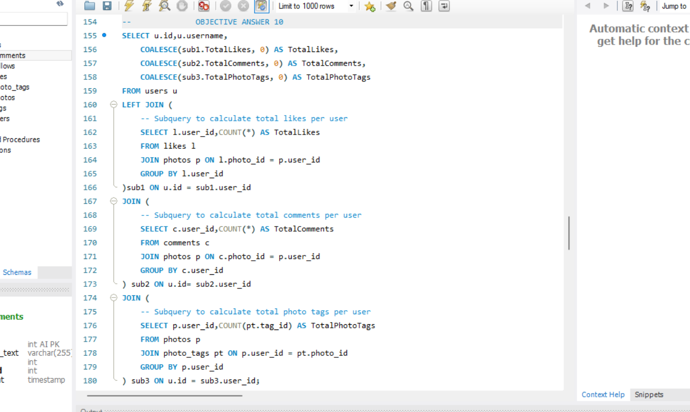

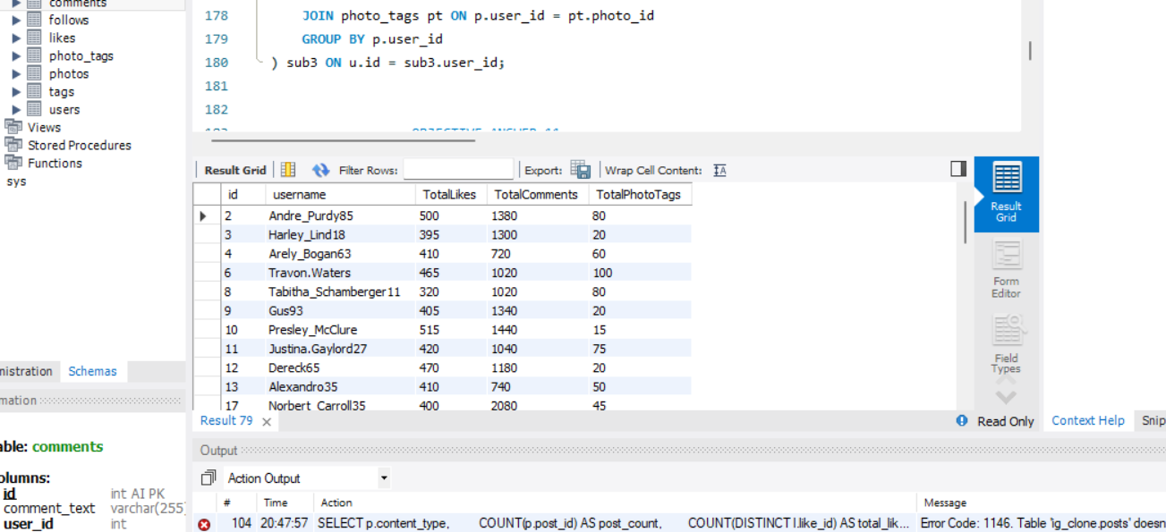

1. Rank users based on their total engagement (likes, comments, shares) over a month.

**Reference:**

Ranking users on their total engagement as follows:

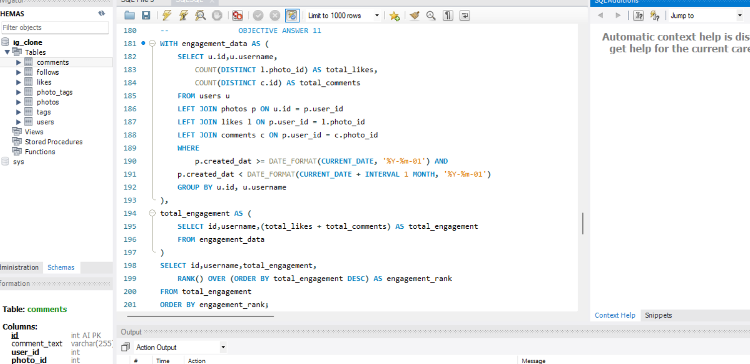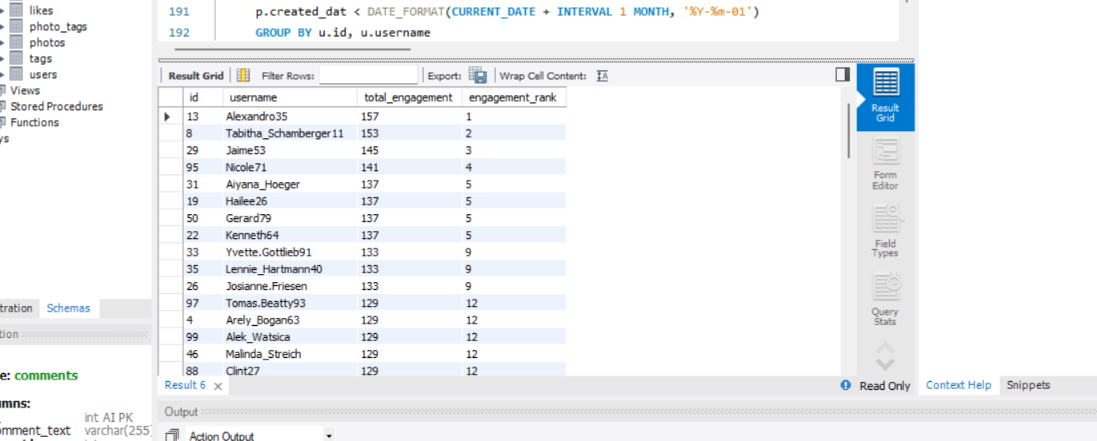

1. Retrieve the hashtags that have been used in posts with the highest average number of likes. Use a CTE to calculate the average likes for each hashtag first.

**Reference:**

Hashtags that have been used in posts with highest average number of likes as follows:

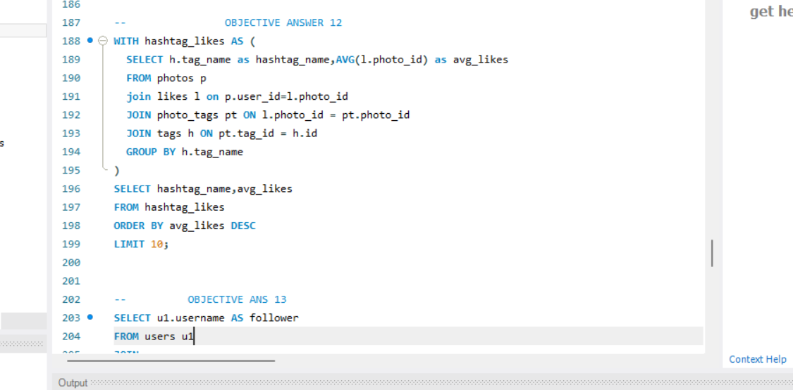

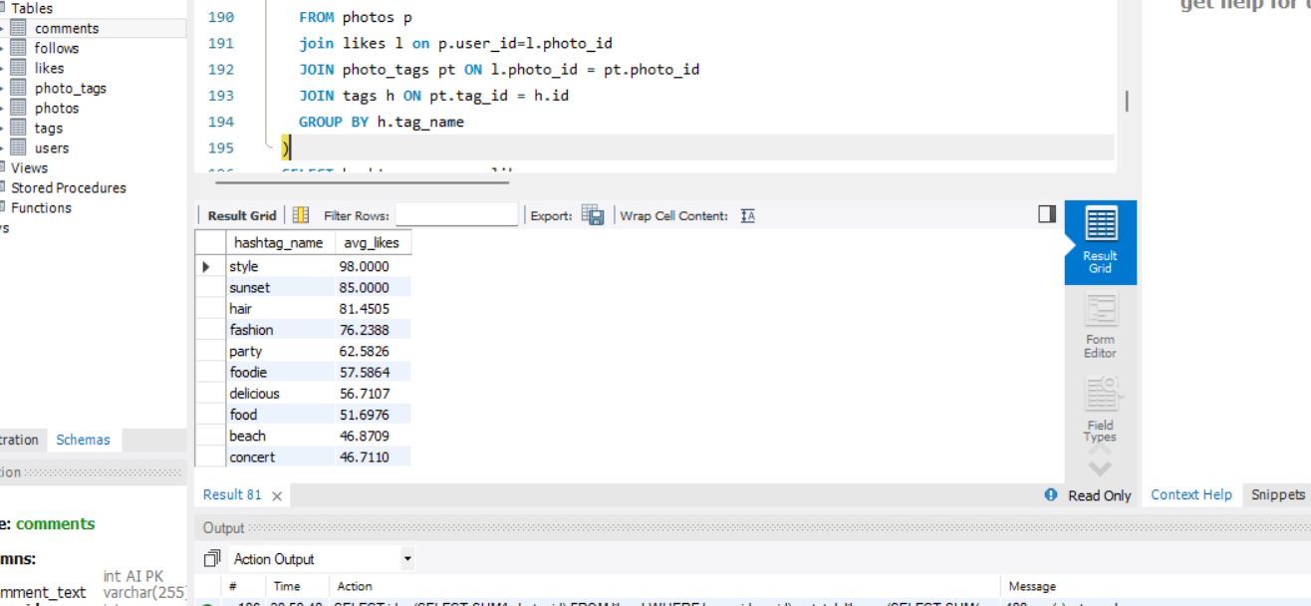

1. Retrieve the users who have started following someone after being followed by that person.

**Reference:**

Users who have started following someone after being followed by that person as follows:

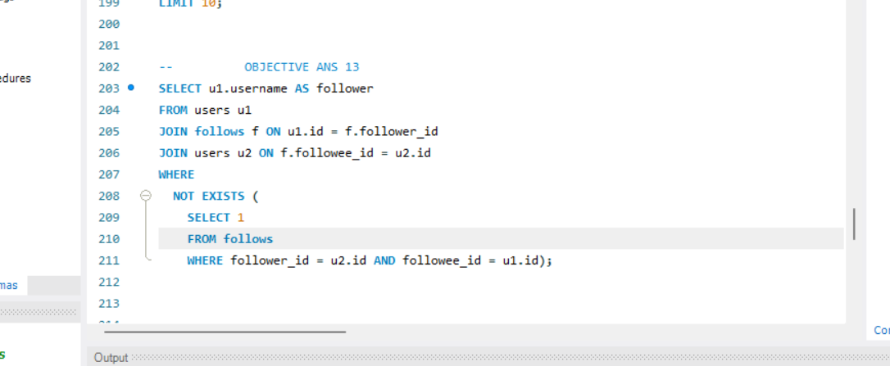

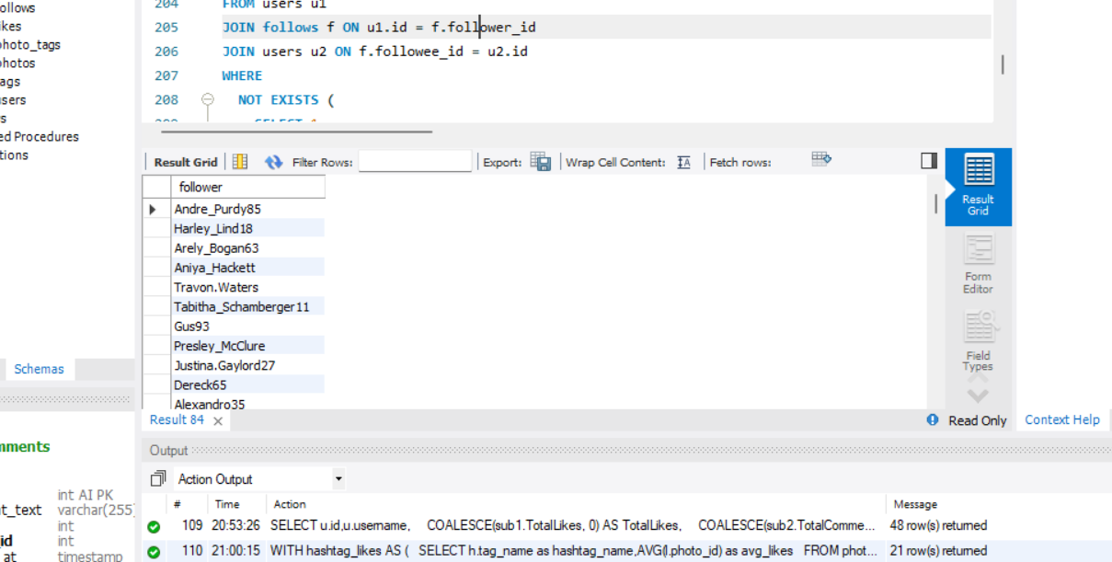

**Subjective Answers:**

1. Based on user engagement and activity levels, which users would you consider the most loyal or valuable? How would you reward or incentivize these users?

**Reference:**

Most loyal or valuable user as follows: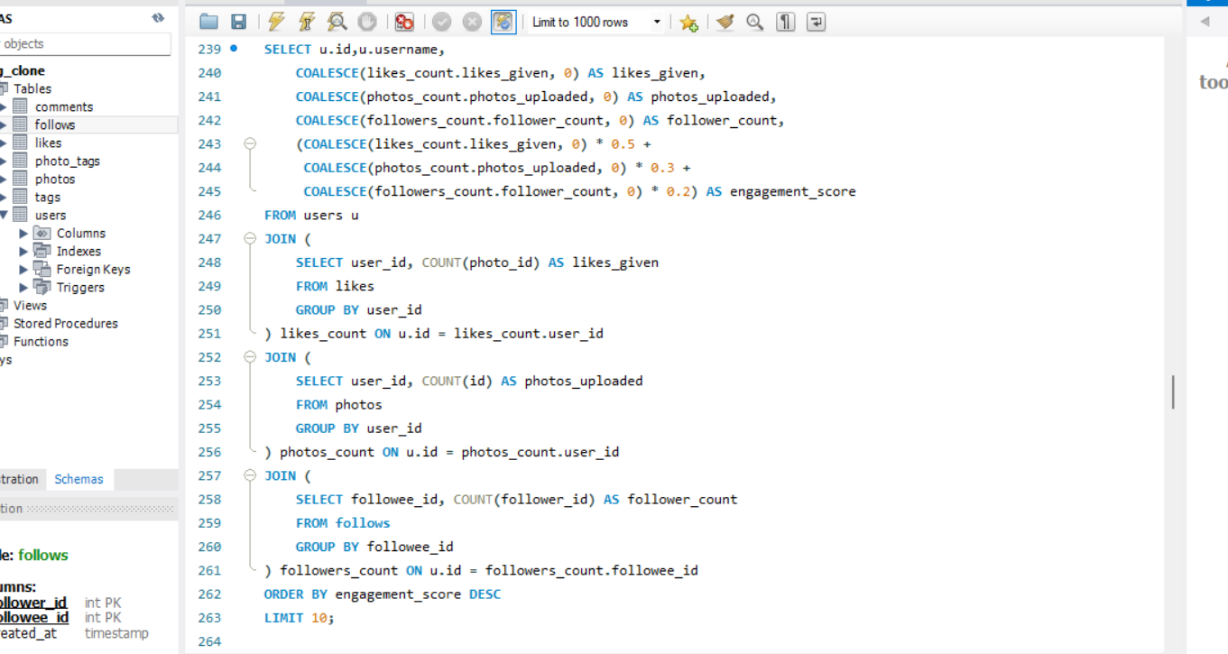

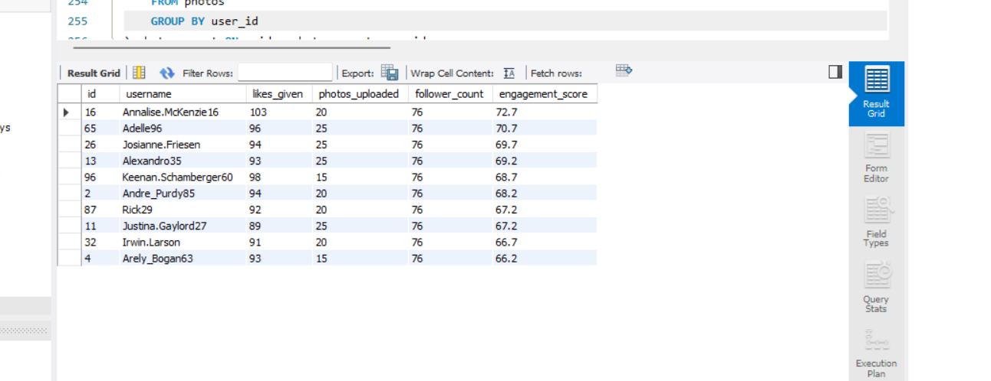

**Rewarding or Incentivizing Loyal Users:**

* By providing loyal users with exclusive discount codes or early access to sales, encouraging continued engagement and purchases.
* Creating a “Fan of the Month” program, recognizing and rewarding the most engaged users with a special feature and a small gift.
* Occasionally send out unexpected gifts or thank-you notes to the most loyal followers, creating a positive emotional connection.
* Inviting loyal users to exclusive online events, product launches, or Q&A sessions, making them feel like part of an insider community.

1. For inactive users, what strategies would you recommend to re-engage them and encourage them to start posting or engaging again?

**Reference:** 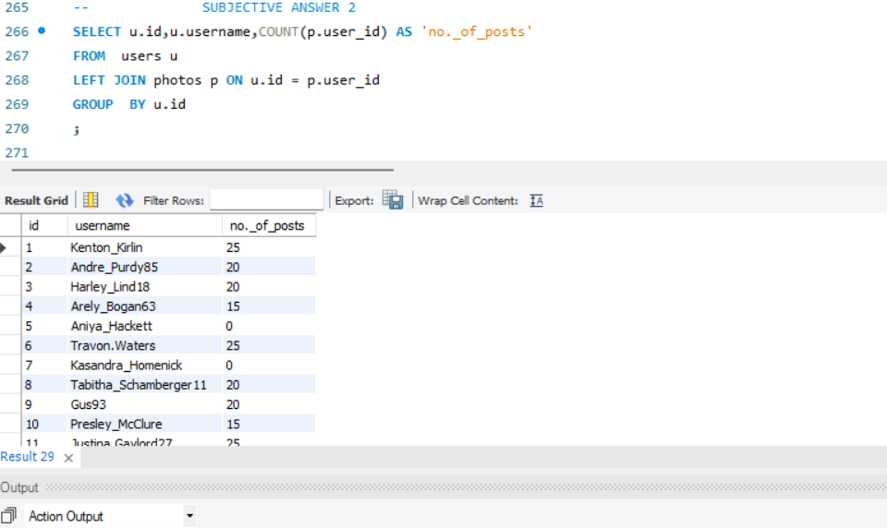

**Visualization:**

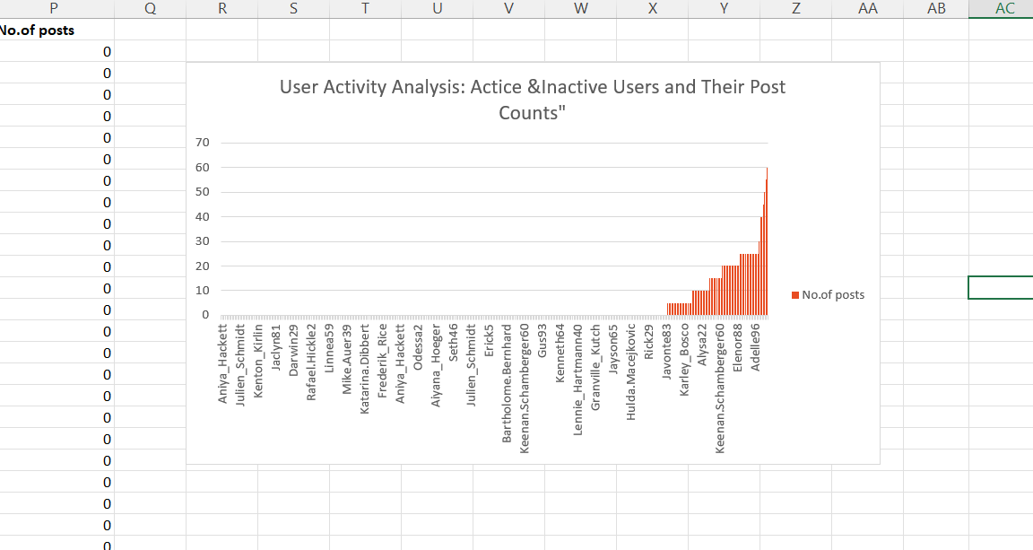

By employing these strategies and utilizing data-driven insights, we can effectively re-engage inactive users.

**Strategies to Re-engage Inactive Users:**

**Special Promotions**: Offer exclusive discounts or limited-time promotions specifically for inactive users, incentivizing them to return and make a purchase.

**Interactive Stories**: Use Instagram Stories to create polls, quizzes, or questions, encouraging users to participate. This low-effort interaction can prompt them to engage more with your content.

**Showcase Others**: Feature user-generated content from active followers in your feed or Stories. This can motivate inactive users to participate by showcasing the community aspect.

**Instagram Ads**: Utilize retargeting ads to remind inactive users of your brand. Showcase products they previously viewed or engaging content they might have missed.

**Surveys and Feedback Requests**: Reach out for their opinions on why they’ve been inactive and what they would like to see. This can help you tailor your strategies and make users feel valued.

1. Which hashtags or content topics have the highest engagement rates? How can this information guide content strategy and ad campaigns?

**Reference:**

Hashtag Researching as follows:



**Visualization:**



Using visualizations like bar charts will help you effectively communicate which hashtags or content topics have the highest engagement rates. This information can be pivotal in guiding your content strategy and optimizing ad campaigns.

**Using Insights to Guide Content Strategy and Ad Campaigns:**

**Content Planning**: Focus on the highest-engagement topics and formats in the content calendar. If tutorials or behind-the-scenes content are performing well, prioritize these in posting strategy.

**Targeted Ad Campaigns**: Utilize insights to create targeted ad campaigns centred around high-engagement topics. Tailor messaging to resonate with users interested in these themes.

**Influencer Collaborations**: Partner with influencers who frequently use high-performing hashtags or create content around trending topics to amplify reach and engagement.

1. Are there any patterns or trends in user engagement based on demographics (age, location, gender) or posting times? How can these insights inform targeted marketing campaigns?

**Reference:**

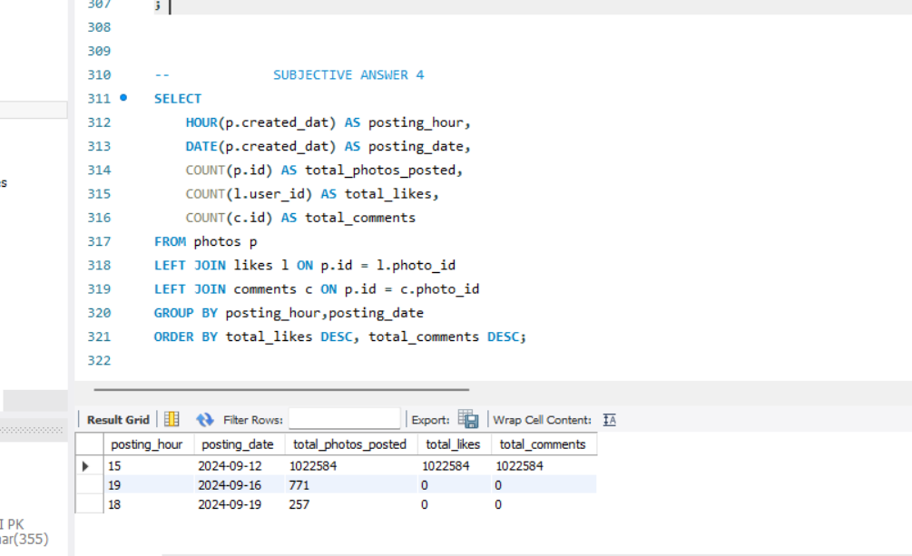

**Visualization:**

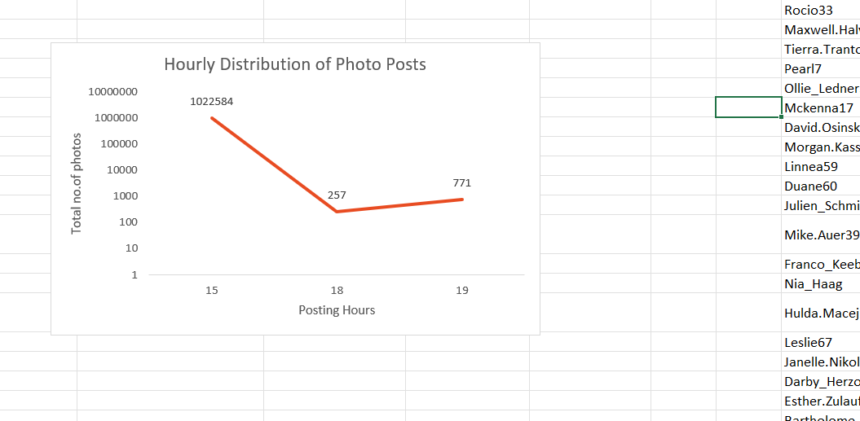

Here’s how to approach this analysis and leverage the findings:

**Insights in User Engagement:**

* + **Day of the Week**: Engagement can fluctuate throughout the week. For instance, users may be more active on weekends or specific weekdays depending on their routines.
  + **Peak Posting Times:** Determine the hours with the highest number of photos posted. This insight reveals when users are most active and inclined to share content.
  + **Patterns and Trends:** Analysing the data for consistency in posting habits. There are some particular hours that consistently show high activity, or spikes at specific times, such as early mornings or late evenings.

**Leveraging Insights for Targeted Marketing Campaigns:**

1. **Content Creation**: Develop content that speaks directly to the preferences of specific demographic segments. For example, create more tutorial and informative content for older audiences, while focusing on visually engaging posts for younger users.
2. **Geo-Targeted Campaigns**: Use location data to run campaigns tailored to specific regions. Highlight local events, community initiatives, or region-specific products to enhance relevance.
3. **Optimal Posting Schedule**: Schedule posts during peak engagement times identified in your analysis. This increases the likelihood of interaction and visibility among your audience.
4. **Engagement Tactics**: Implement demographic-specific engagement tactics, such as polls or questions in Stories that are tailored to the interests of specific age groups or genders.
5. **Influencer Collaborations**: Partner with influencers who resonate with your target demographics. Ensure their audience aligns with your brand’s target market for maximum impact.
6. Based on follower counts and engagement rates, which users would be ideal candidates for influencer marketing campaigns? How would you approach and collaborate with these influencers?

**Reference:**

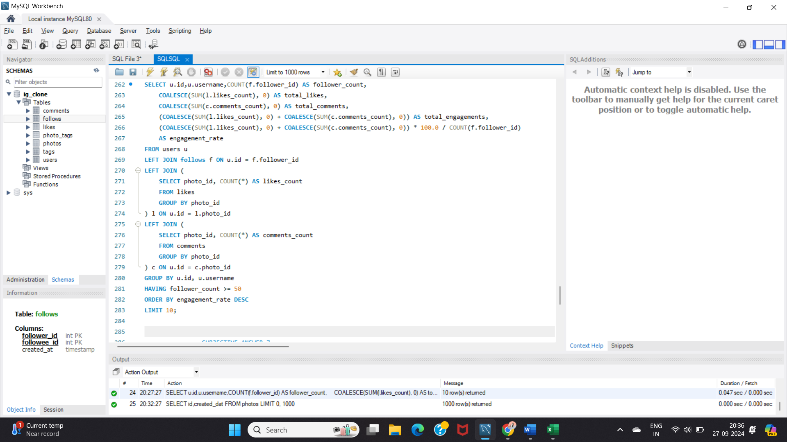

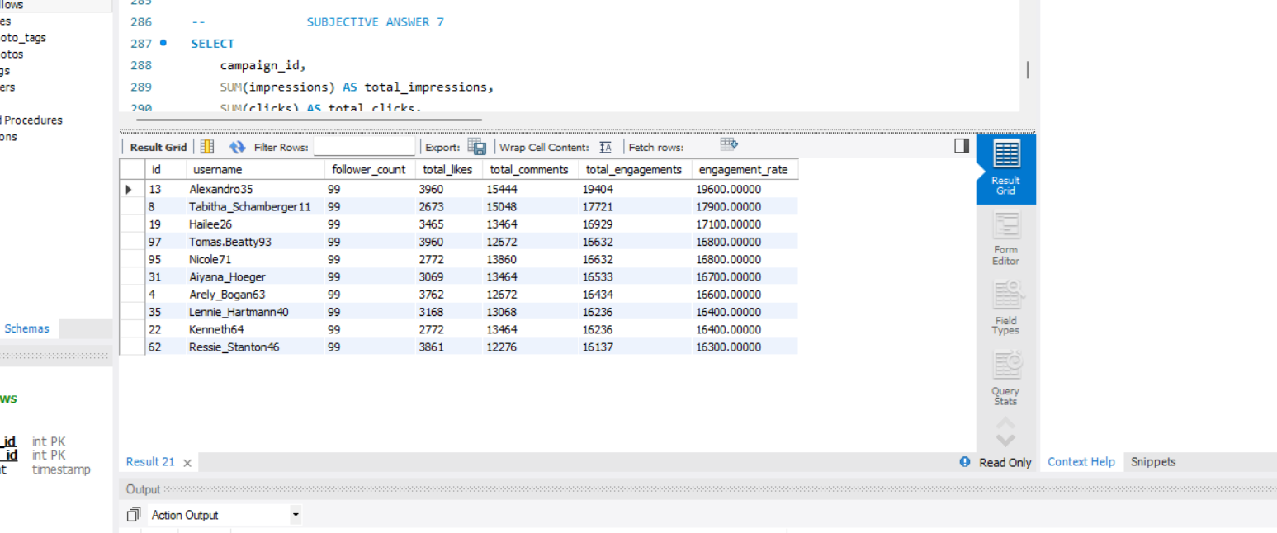

**Approaching and Collaborating with Influencers:**

**Collaboration Ideas**: Propose specific campaign ideas, such as product reviews, giveaways, or co-hosting events. Encourage creativity and allow influencers to contribute their ideas to the collaboration.

**Contracts and Guidelines**: Establish clear terms of collaboration, including deliverables, timelines, and compensation. Provide brand guidelines to ensure the content aligns with your brand’s messaging while allowing for the influencer’s personal style.

**Track Performance**: Use analytics tools to track the performance of the influencer campaign, assessing reach, engagement, and conversions. Use these insights to refine future influencer partnerships.

1. Based on user behaviour and engagement data, how would you segment the user base for targeted marketing campaigns or personalized recommendations?

**Reference:**

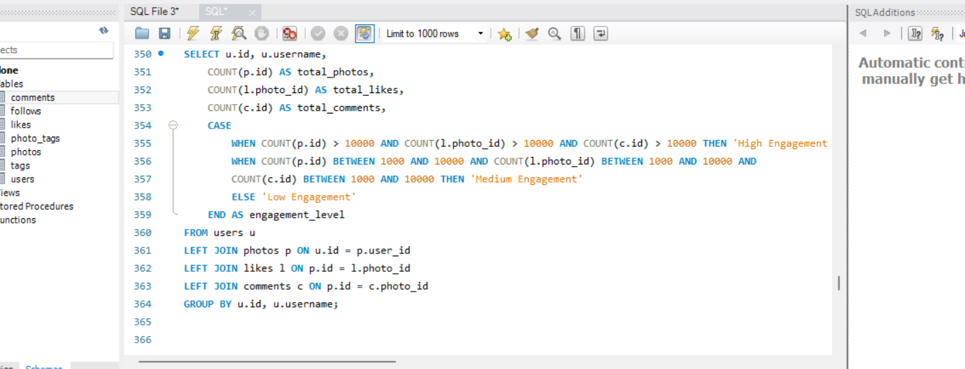

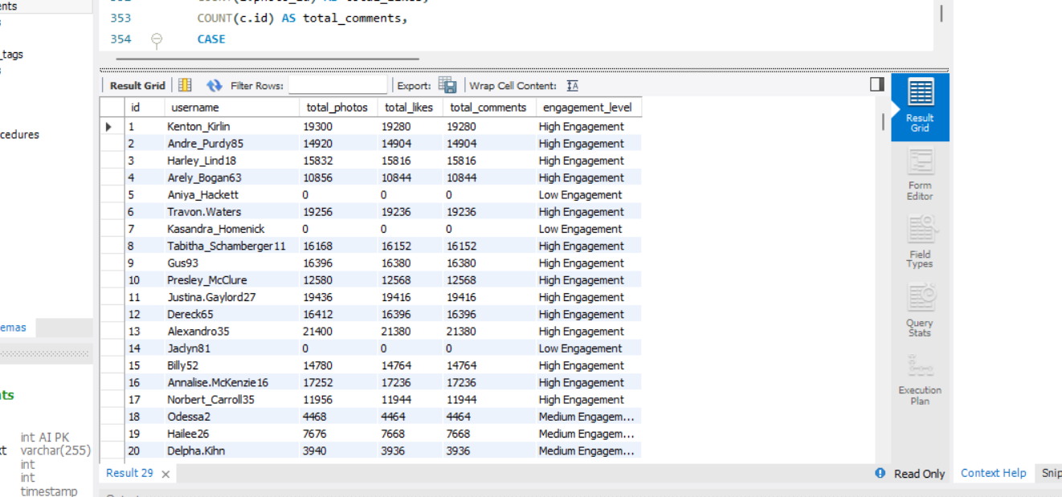

**Implementing Segmentation for Campaigns:**

* **Targeted Marketing:** Create tailored marketing campaigns for each segment to maximize effectiveness.
* **Content Strategy:** Use insights from high-engagement users to refine and optimize content types that resonate with your audience.
* **User Feedback:** Regularly collect feedback from all segments to continuously improve user experience and address pain points.
* **Monitor Trends:** Regularly analyze engagement metrics over time to identify shifts in user behaviour and adapt strategies accordingly.

By leveraging these insights, we can develop a more effective marketing strategy that caters to the diverse needs of our user base, ultimately driving higher engagement and retention.

1. If data on ad campaigns (impressions, clicks, conversions) is available, how would you measure their effectiveness and optimize future campaigns?

**Assuming you have a table called ad_campaigns with the following columns:** campaign_id, impressions, clicks, conversions, revenue, cost, campaign_date

**Reference:**

Here's an SQL query to calculate these metrics for each campaign:

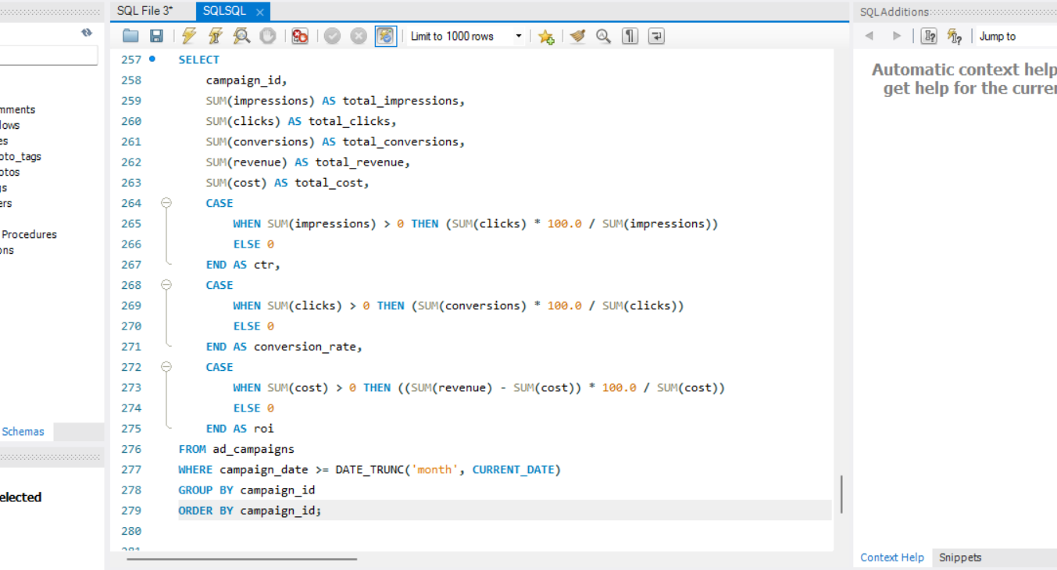

Assuming revenue_per_conversion is a known constant, here’s a sample output from the query:

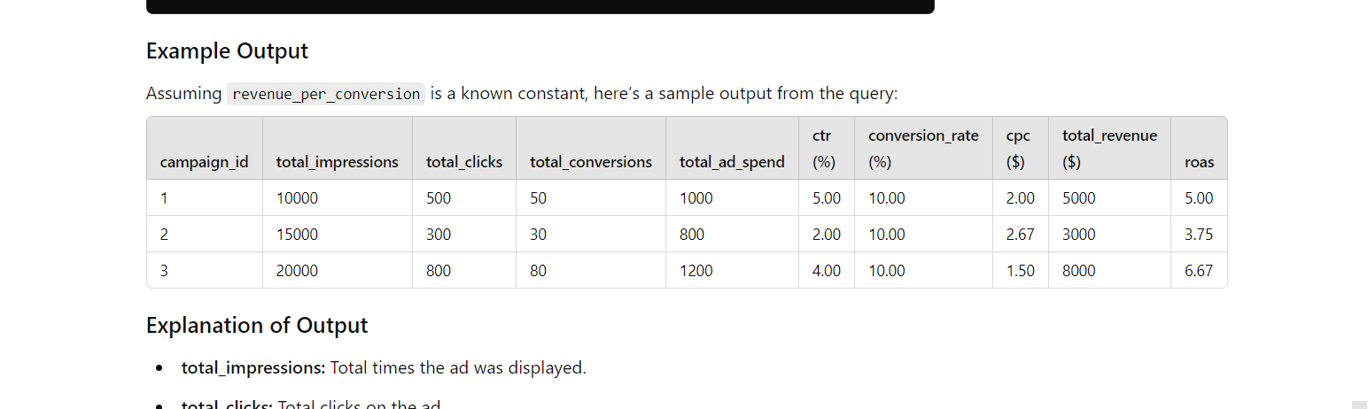

**Approach to Measuring Effectiveness:**

1. **Data Collection:**
   * Utilize tracking tools (like Google Analytics, Facebook Ads Manager, etc.) to gather data on impressions, clicks, conversions, and ad spend.
2. **Analysis of Performance:**
   * **Segmentation:** Analyze data by audience demographics, geographic location, device, and ad format to identify which segments perform best.
   * **A/B Testing:** Implement tests to compare different ad creatives, targeting options, and messaging to determine what works most effectively.
3. **Attribution Analysis:**
   * Understand the customer journey by analyzing which touchpoints contribute most to conversions. This could involve multi-channel attribution models.

**Optimizing Future Campaigns:**

1. **Refine Targeting:**
   * Use insights from performance analysis to adjust targeting, focusing on high-performing demographics and segments.
2. **Enhance Creative Elements:**
   * Update ad visuals, copy, and calls-to-action based on performance data. For example, if certain messaging resonates more, incorporate it into future campaigns.
3. **Adjust Budget Allocation:**
   * Shift budget towards channels and campaigns that demonstrate higher ROI and performance metrics.
4. **Continuous Testing:**
   * Maintain an iterative approach, continuously testing new ideas, creatives, and strategies to find better-performing combinations.
5. **Regular Reporting:**
   * Establish a reporting cadence to regularly review performance metrics, allowing for timely adjustments and informed decision-making.
6. How can you use user activity data to identify potential brand ambassadors or advocates who could help promote Instagram's initiatives or events?

**References:**

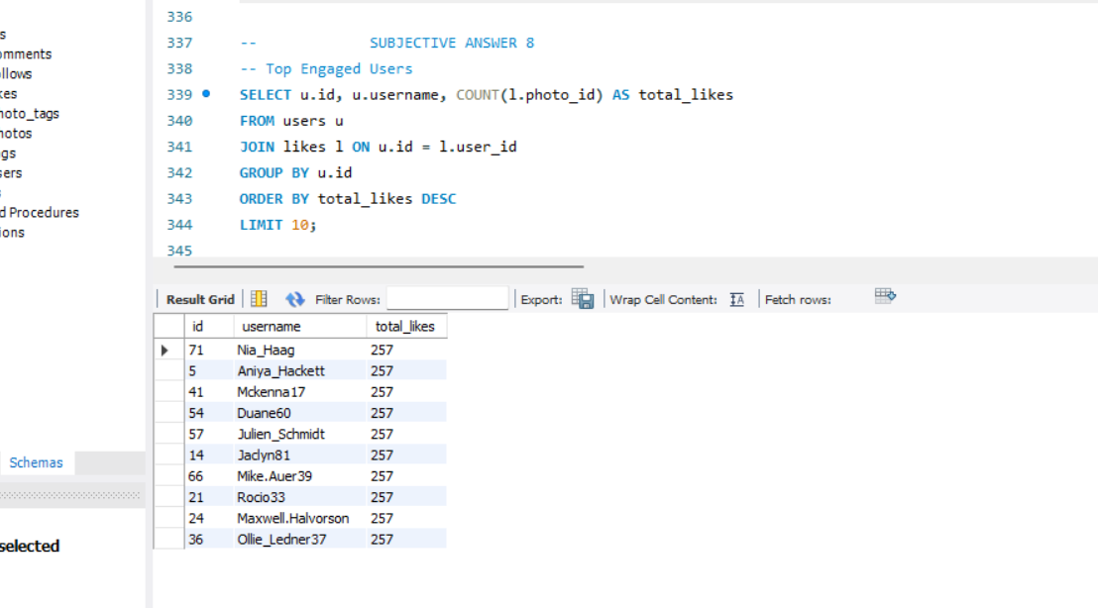

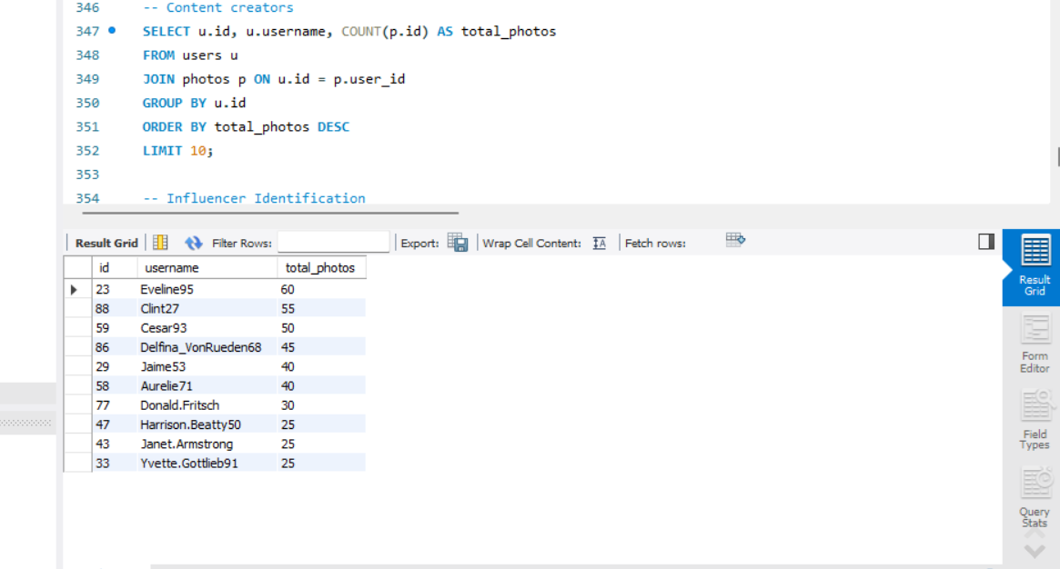

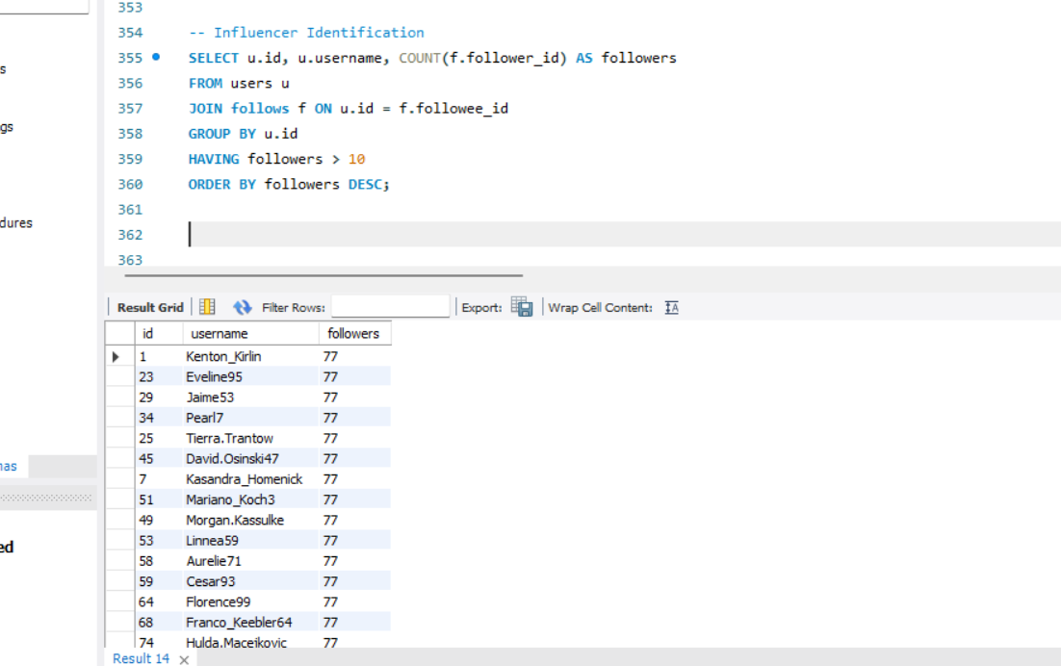

Here’s how you can leverage this data effectively:

**1. Engagement Metrics Analysis:**

* **Likes, Comments, and Shares**: Identify users who consistently engage with your content (e.g., high likes and comments on posts). These users demonstrate a genuine interest in your brand.
* **Post Interactions**: Look for users who actively share your posts or mention your brand in their content, indicating a willingness to advocate for you.

**2. Content Creation Frequency:**

* **User-Generated Content**: Track users who create and share content featuring your products or services. This includes photos, reviews, and stories. Frequent content creators are likely to be enthusiastic advocates.
* **Hashtag Usage**: Monitor the use of branded hashtags. Users who frequently incorporate these into their posts can be potential ambassadors.

**3. Community Engagement:**

* **Followers and Engagement**: Identify users with a significant number of followers who also engage with your content. Their influence can help amplify your brand’s message.
* **Group Participation**: Analyze involvement in community groups or discussions related to your brand. Active participants can serve as effective advocates.

**4. Demographics and Interests:**

* **Targeted Segmentation**: Use demographic data to identify users who align with your brand values and target audience. Look for alignment in interests, lifestyles, and values.
* **Interest-Based Clusters**: Analyze users’ interactions with specific types of content (e.g., sustainability, fashion) to find advocates who resonate with particular brand initiatives.

**5. Sentiment Analysis:**

* **Positive Feedback**: Use sentiment analysis on comments and messages to identify users who express positive feelings about your brand. Users with a strong positive sentiment are more likely to become advocates.
* **Feedback and Suggestions**: Pay attention to users who provide constructive feedback and show a vested interest in your brand’s growth.

**6. Event Participation:**

* **Engagement in Events**: Monitor users who actively participate in your events, webinars, or live sessions. High engagement during these events can indicate a willingness to promote your initiatives further.
* **Event Sharing**: Look for users who share event details with their networks or create content around your events.

**7. Personalized Outreach:**

* **Direct Engagement**: Reach out to identified potential advocates with personalized messages expressing appreciation for their support. Invite them to participate in exclusive campaigns or initiatives.
* **Incentives for Advocacy**: Offer incentives such as early access to products, exclusive content, or co-branding opportunities to encourage advocacy.

1. How would you approach this problem, if the objective and subjective questions weren't given?

If the objective and subjective questions weren't provided, I would approach the problem of identifying potential brand ambassadors or advocates by following these steps:

**1. Define the Objectives**

* **Clarify Goals**: Determine what you want to achieve with the campaign (e.g., increasing brand awareness, promoting a specific product, or driving engagement).
* **Target Audience**: Identify the target audience for your brand ambassadors based on demographic, geographic, and psychographic factors.

**2. Data Collection**

* **User Activity Data**: Gather data on user interactions, such as likes, comments, shares, and content creation related to your brand.
* **Engagement Metrics**: Focus on metrics that indicate engagement levels, such as frequency of interactions, types of content engaged with, and duration of interactions.
* **Content Analysis**: Collect qualitative data by analyzing user-generated content to understand themes, sentiments, and brand affinity.

**3. Data Analysis**

* **Engagement Patterns**: Use statistical methods to identify users with high engagement rates. Look for trends and patterns in user behavior.
* **Social Listening Tools**: Employ tools to monitor brand mentions and sentiment across social platforms to gauge user attitudes toward the brand.
* **Segmentation**: Segment users based on their engagement levels, content preferences, and demographics to identify key groups of interest.

**4. Identify Potential Advocates**

* **Create a Scoring System**: Develop a scoring system to rank users based on engagement metrics, content creation frequency, and sentiment scores.
* **Influencer Identification**: Look for users who fit the profile of micro-influencers, including engagement rates and audience alignment.

**5. Develop a Strategy for Engagement**

* **Engagement Plan**: Formulate a plan to engage identified advocates, which might include outreach for collaboration, exclusive content access, or invitations to events.
* **Incentive Structures**: Consider how to motivate these advocates, whether through rewards, recognition, or other benefits.

**6. Monitor and Optimize**

* **Continuous Monitoring**: Set up a system for ongoing monitoring of advocate engagement and brand performance.
* **Adjust Strategies**: Use data-driven insights to continually optimize the strategy, refining your approach based on what works best.

**7. Report Findings**

* **Data Presentation**: Prepare a report summarizing findings, including metrics on engagement, brand sentiment, and the effectiveness of ambassador outreach.
* **Recommendations**: Offer actionable recommendations based on insights gained from the analysis.

1. Assuming there's a "User_Interactions" table tracking user engagements, how can you update the "Engagement_Type" column to change all instances of "Like" to "Heart" to align with Instagram's terminology?

**Reference:**

Here’s the alignment as follows:

